Abhishek Ojha

Seat No 027

PRACTICAL NO 1

Global Schema in DDB

**Practical No: 1**

**Aim:** For a given a global conceptual schema, divide the schema into horizontal and vertical fragmentation and place them on different nodes. Execute queries on these fragments that will demonstrate distributed databases environment.

**Software Requirement:**

Oracle Database 11g.

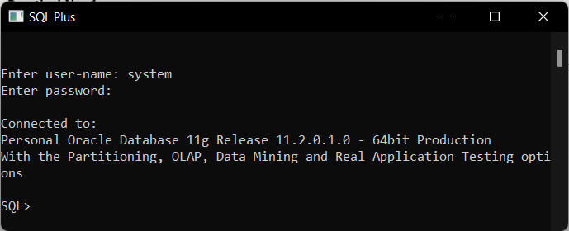

**How to Create Two Database**

**Steps to Create Database db1 and db2**

**Step 1:-** Open Start Menu on Window Explorer Go to Database Configuration Assistant.

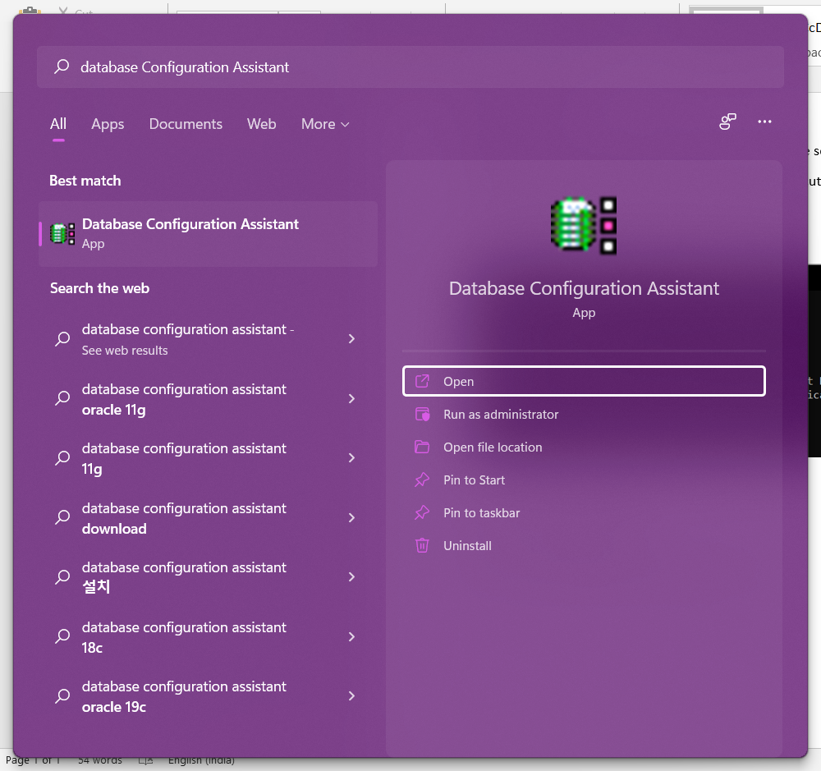

**Step 2:** Click on Next.

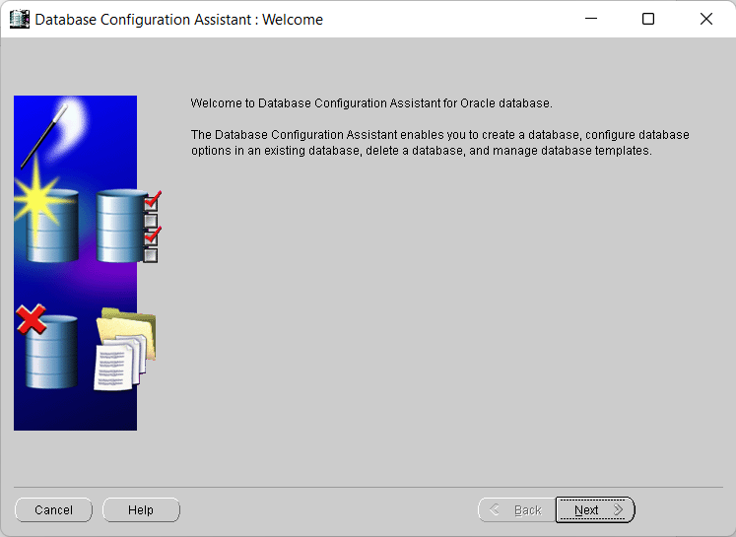

**Step 3:** Select Option Create a Database.

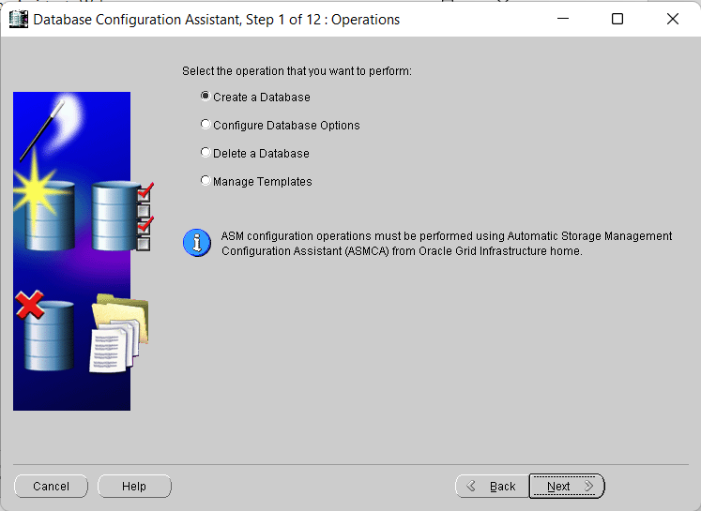

**Step 4:** Select Option General Purpose or Transaction Processing or You can Create your Own Custom Database.

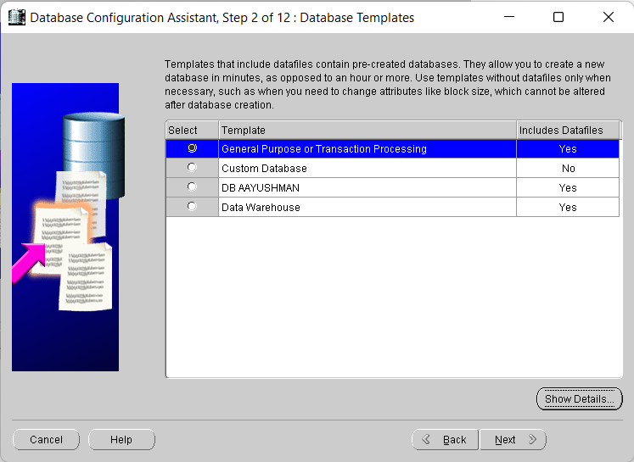

**Step 5:** Give Database Name as db1 (of your own choice).

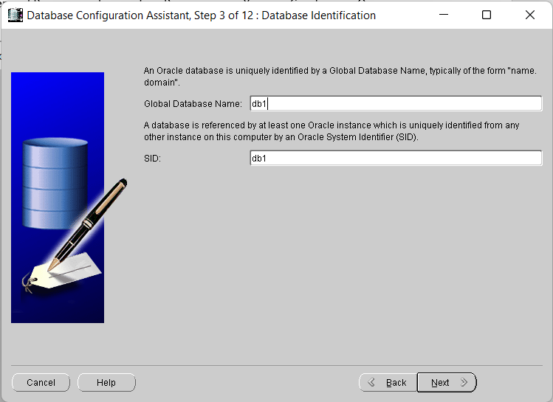

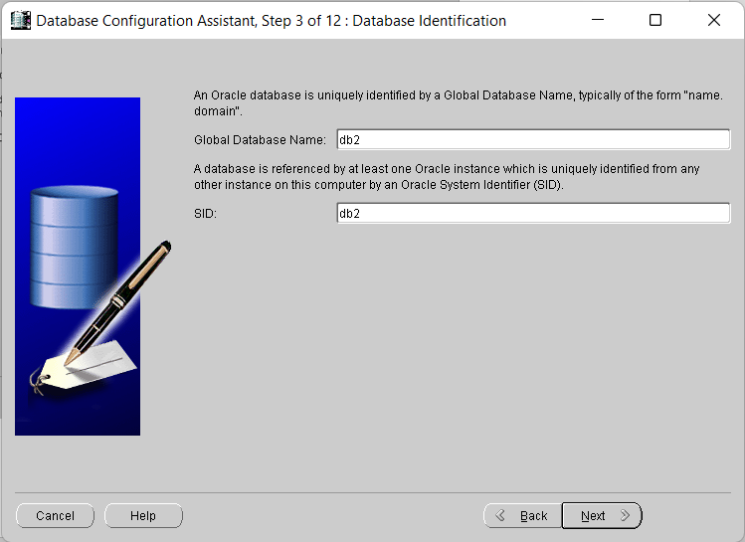

**Step 6:** No changes Needed, Click on Next.

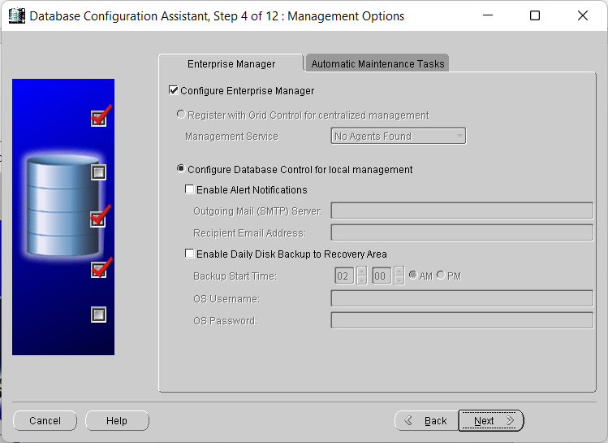

**Step 7:** Input Password of your choice for Each Fields or Else use your Administrator Credentials for all Profile.

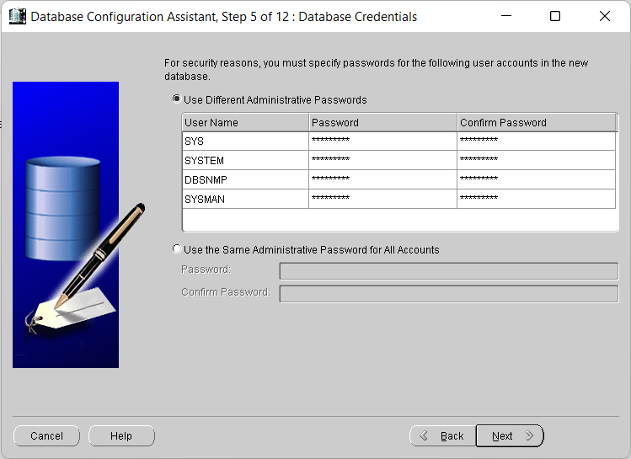

Checks for Password Confirmation, Just Click Yes.

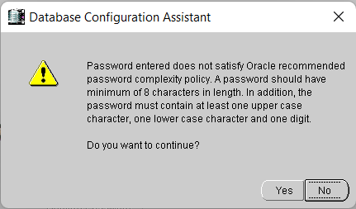

**Step 8:** No changes Needed, Click on Next.

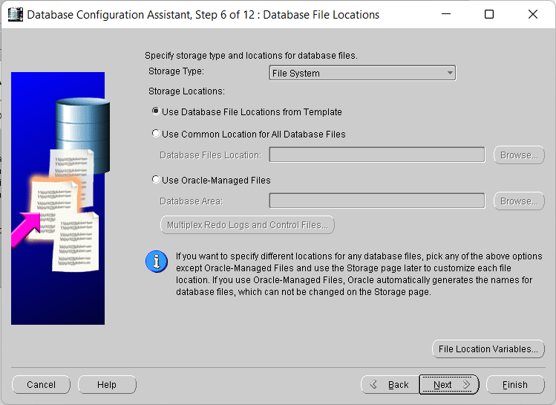

**Step 9:** No changes Needed, Click on Next.

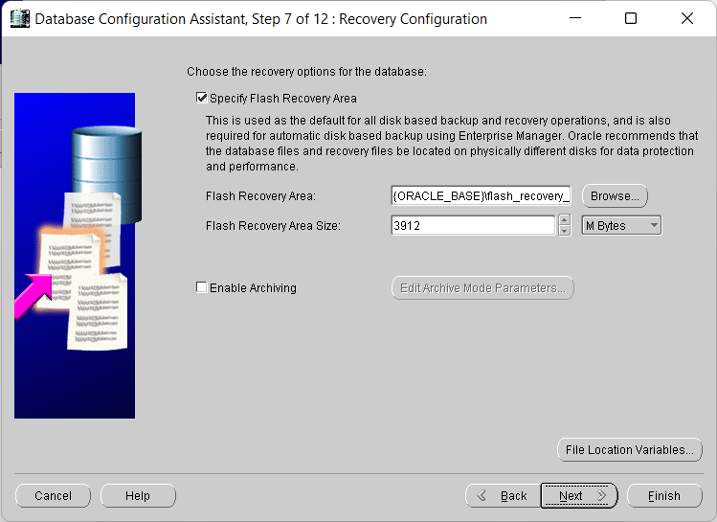

**Step 10:**  No changes Needed, Click on Next.

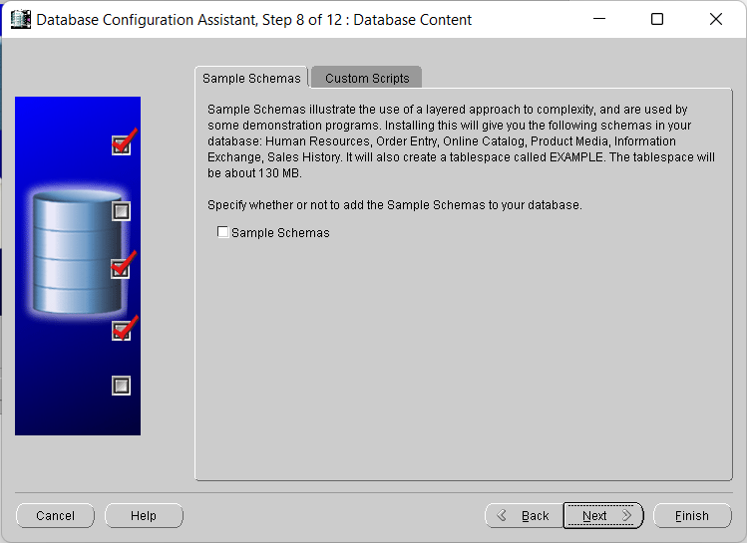

**Step 11:** No changes Needed, Click on Next.

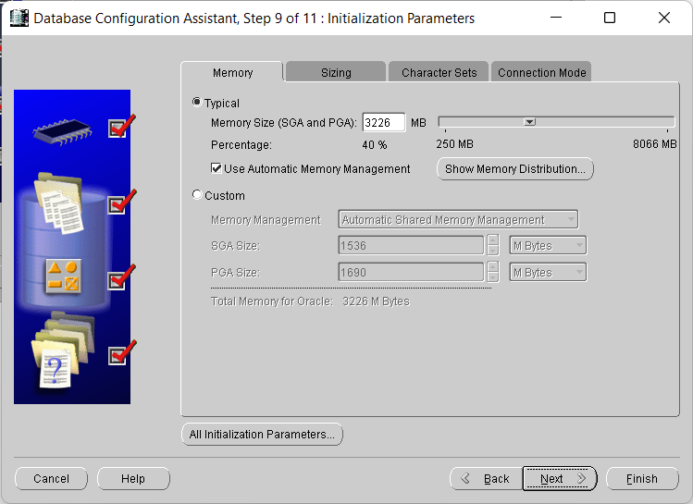

**Step 12:** No changes Needed, Click on Next..

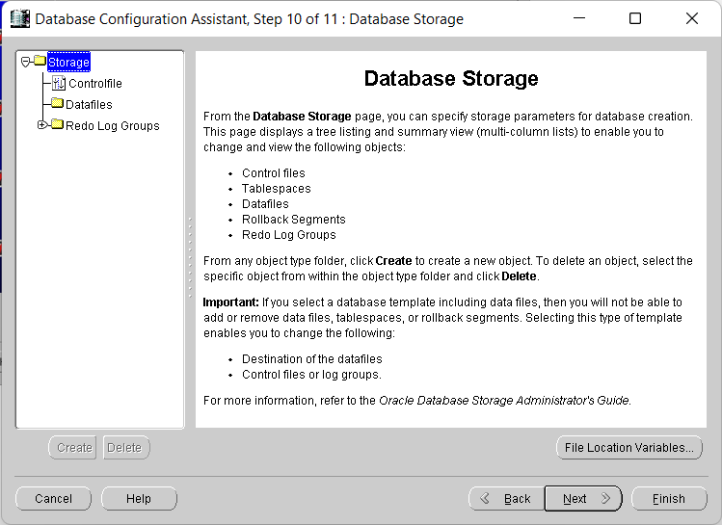

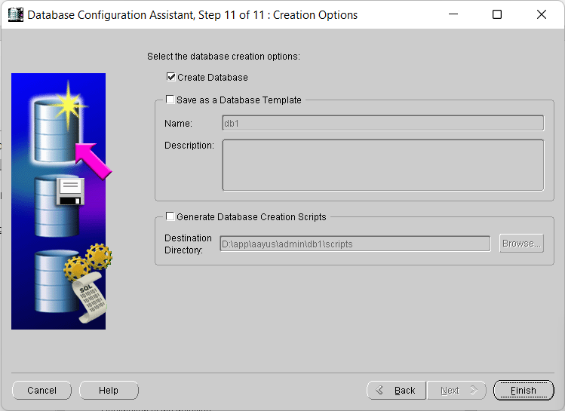**Step 13:** No changes Needed, Click on Finish.

Confirmation of Creating Database, You can Save it as well for your database details. Incase you forget credentials for your database, you can take help of this file to get access of your database.

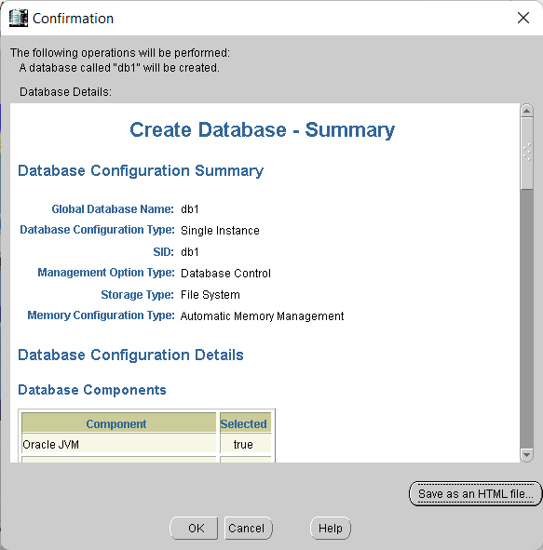

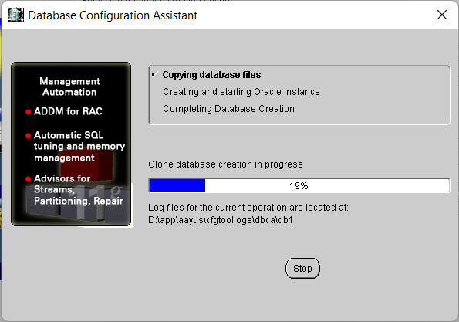

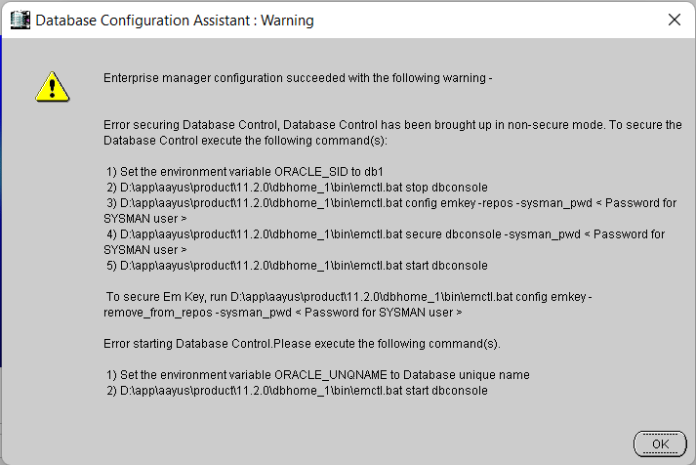

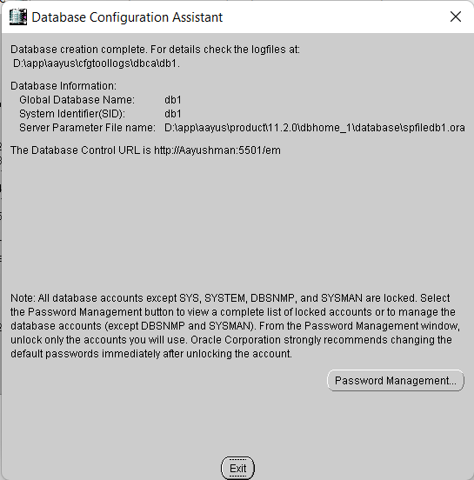

Click on Exit and Done…..

**Follow the Same Steps to create db2,**

Once done with Creating db1 and db2 .

**Practical Implementation Steps:**

* **Step 1:-** Open SQLPlus.

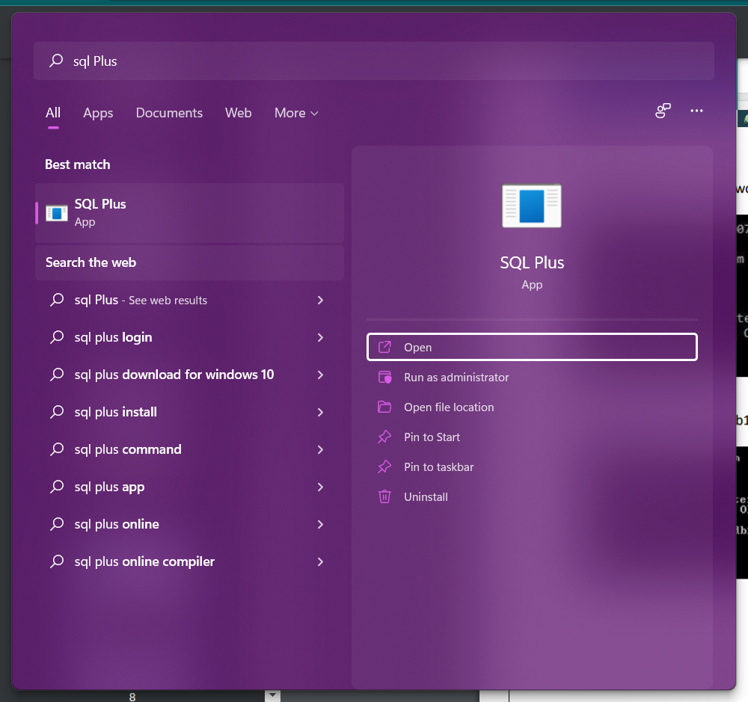

* **Step 2:** Connect to Your Database .

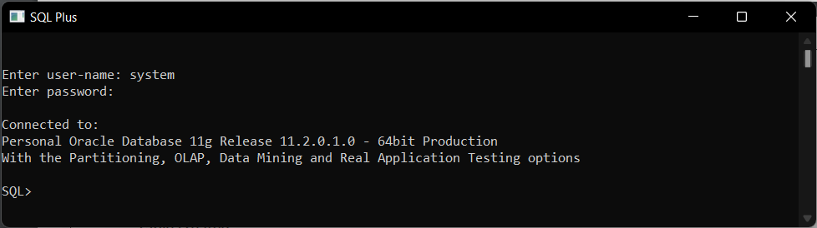

* **Step 3:** Connect your db1 While executing the Command

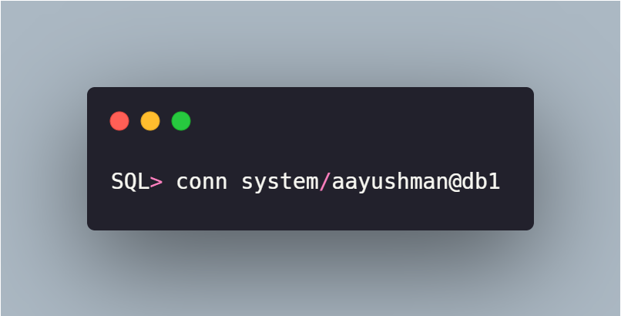

[Where “aayushman” is password of your database, and “db1” is database name].

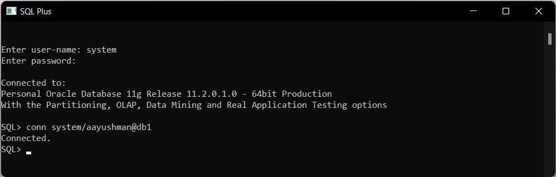

* **Step 4:** Create one table in database db1.

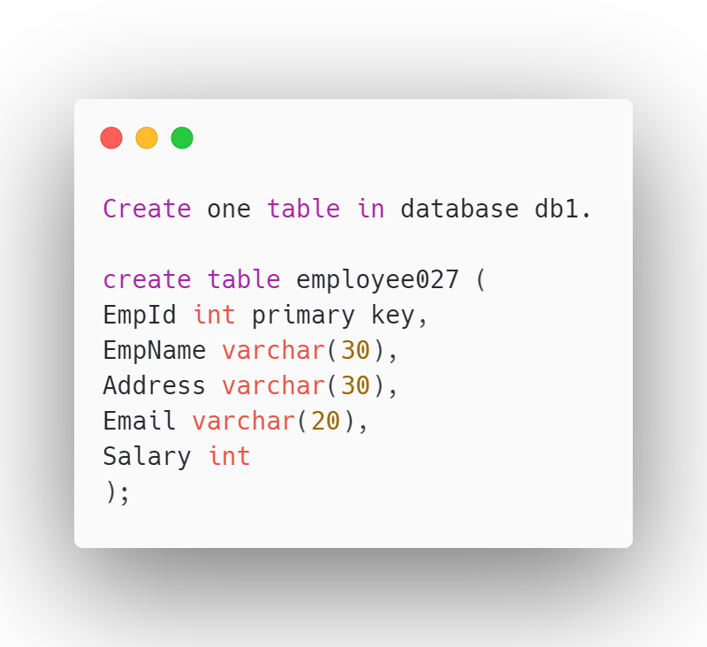

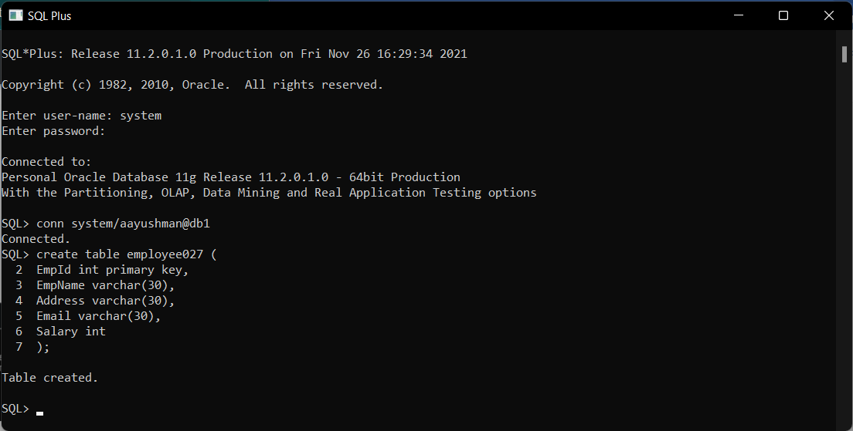

* **Step 5:** Insert Some values in Created Table.

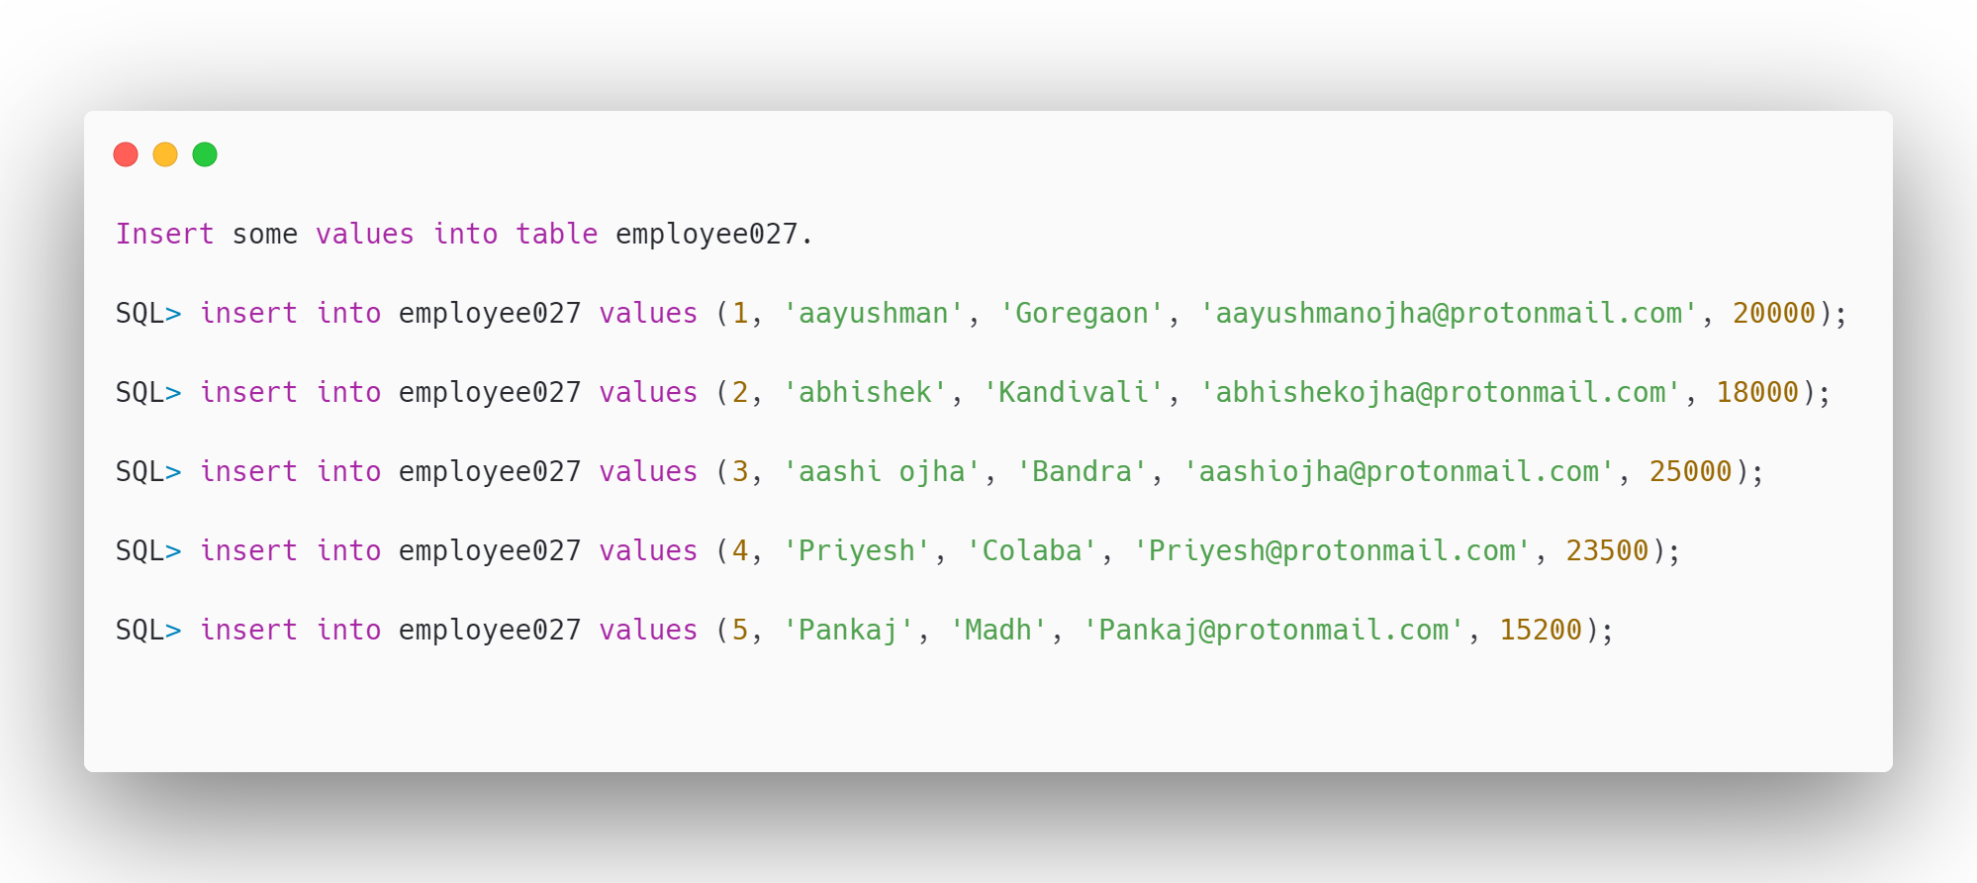

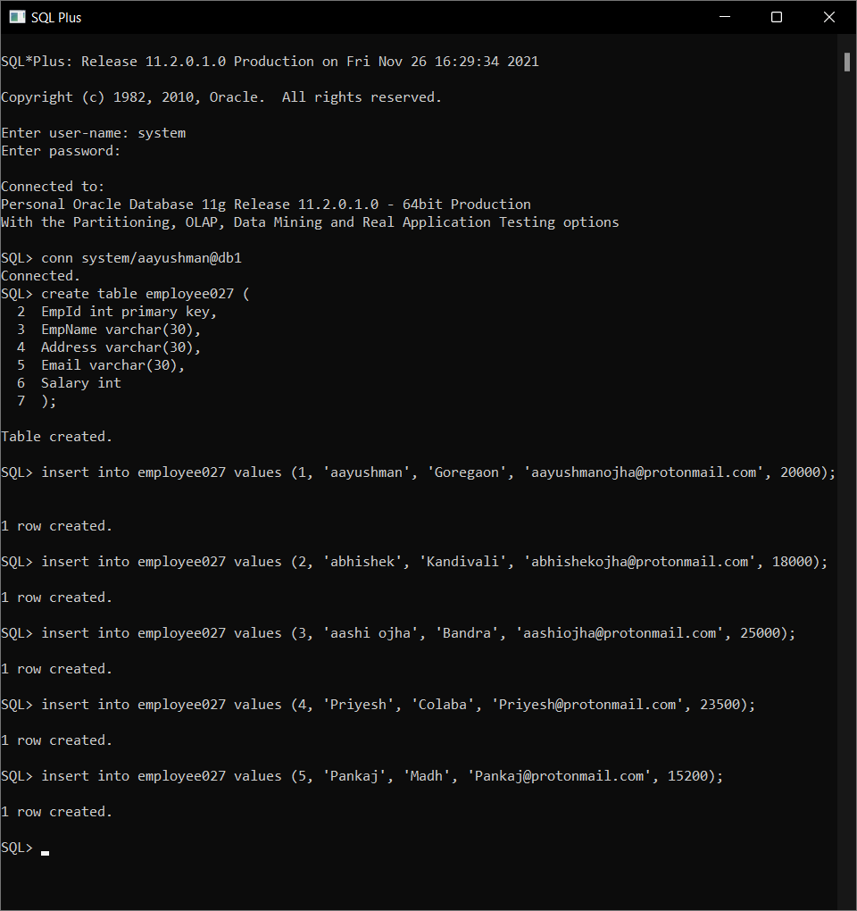

* **Step 6:**

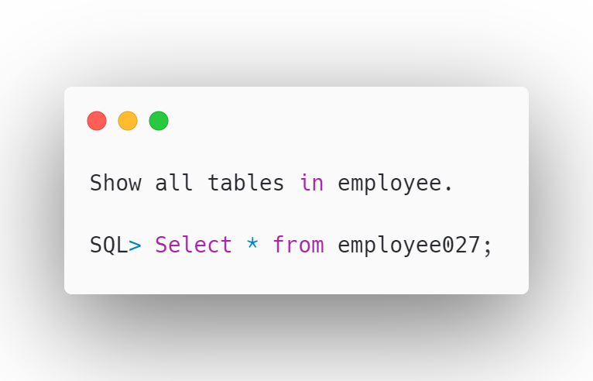

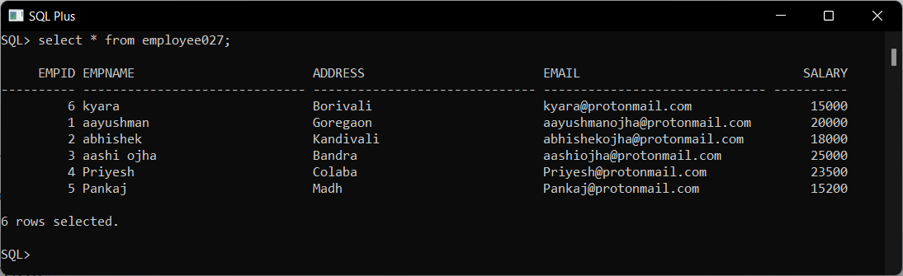

* **Step 7:** Enter following command to create link between two databases.

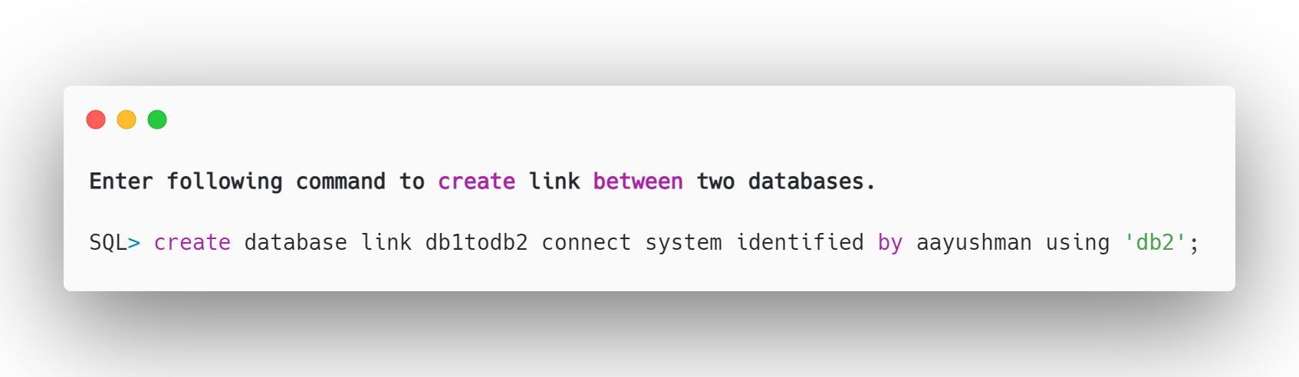

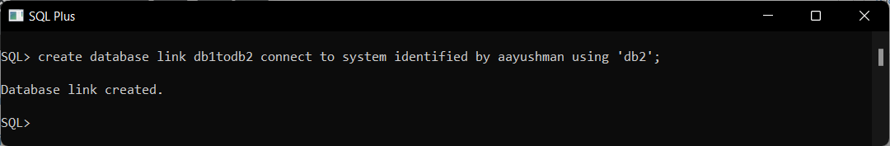

* **Step 8:** Connect to Db2.

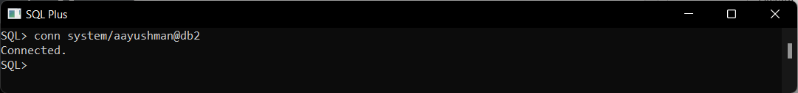

* **Step 9:** Create link to connect db1.

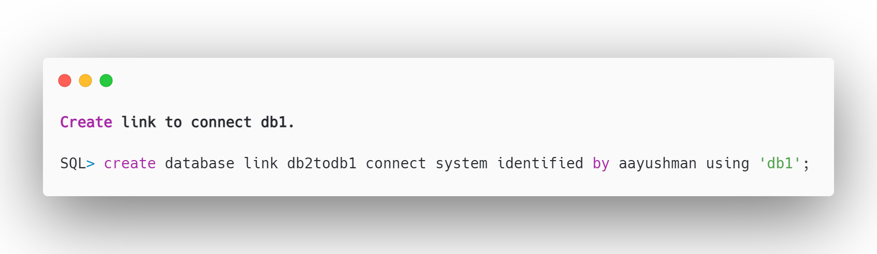

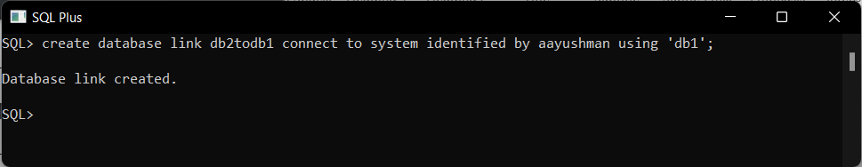

* **Step 10:** Create emp1 select where salary<18000.

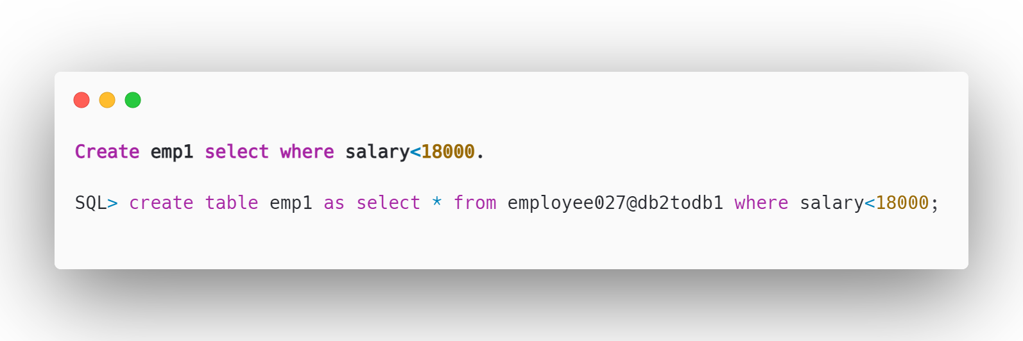

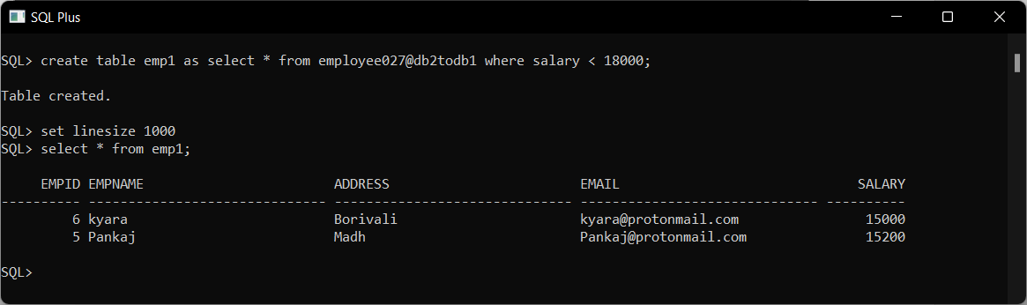

* **Step 11:** Create table emp2 where address='Bandra’.

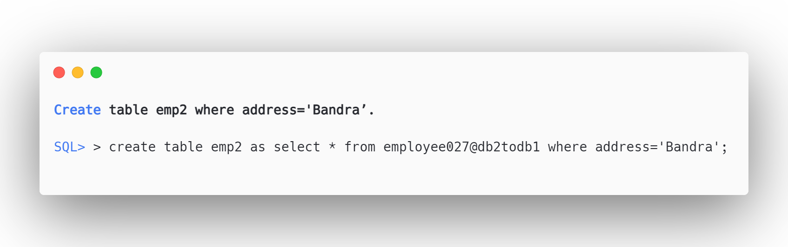

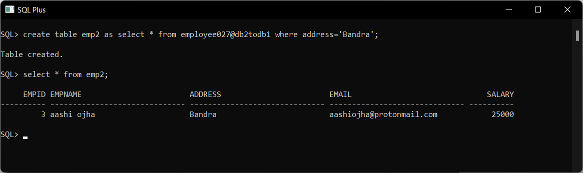

* **Step 12:** Select salary from employee.

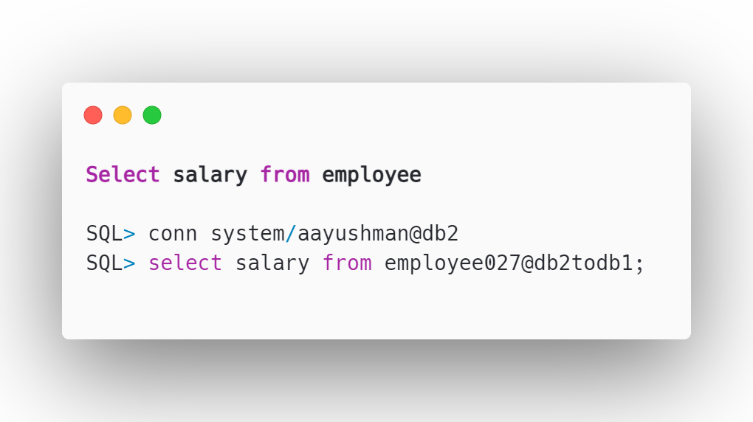

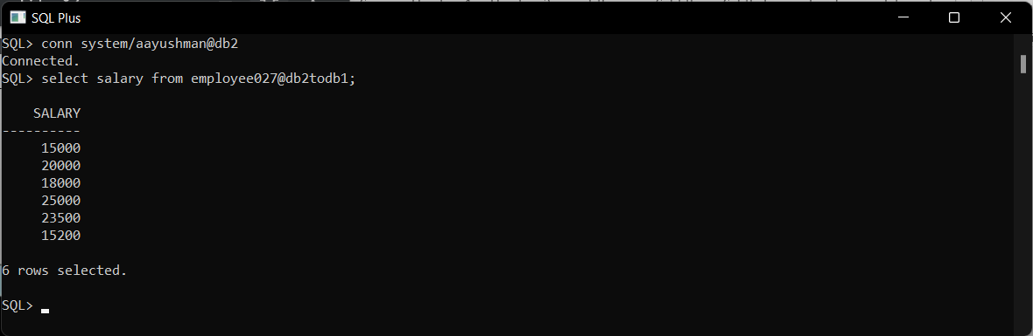

* **Step 13:** Select mail whose salary>16000.

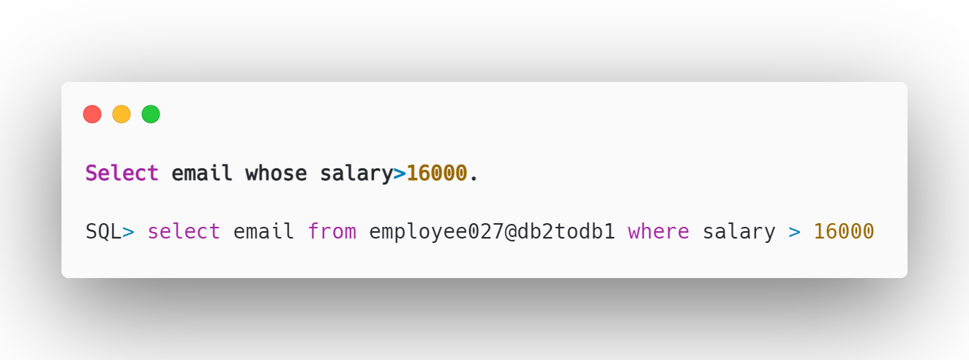

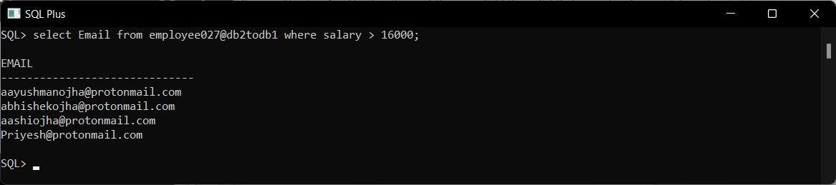

* **Step 14:** Select Employee Name and Email from Employee table where eid=2.

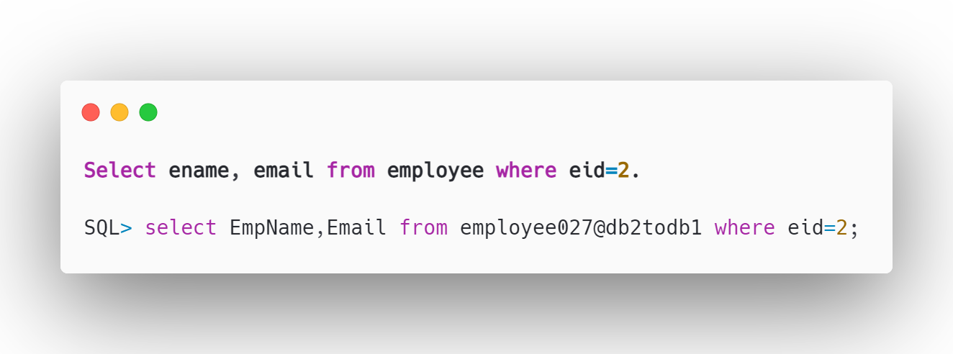

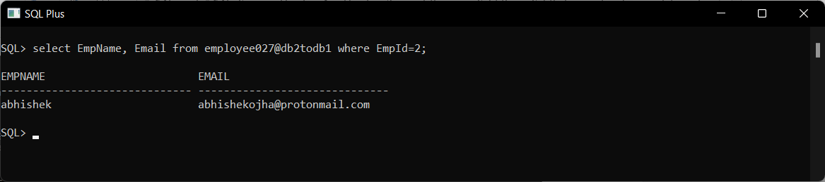

* **Step 15:** Create table emp3 where address='Madh'.

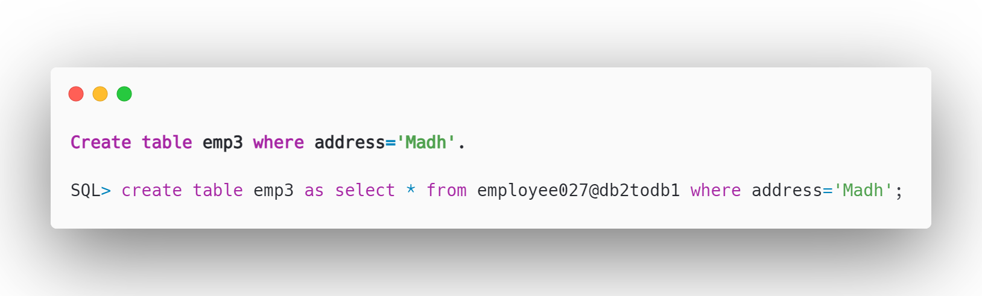

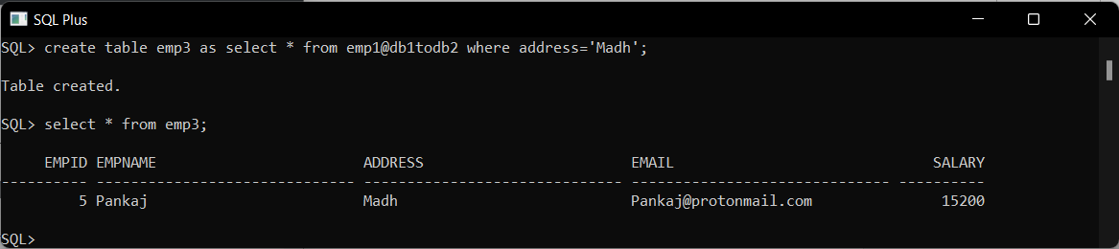

**Conclusion:** Successfully Execution of Schema into horizontal and vertical Fragmentation on different nodes in Distributed Database Environment.